CL30001 – Computer Networks

Quiz 01

**Student Name: Qasim ali Roll No. 20P-0070**

Time Allowed: **30 minutes** **Total Marks: 20 Weightage: 2**

Q1: Consider the following topology and populate the tables:

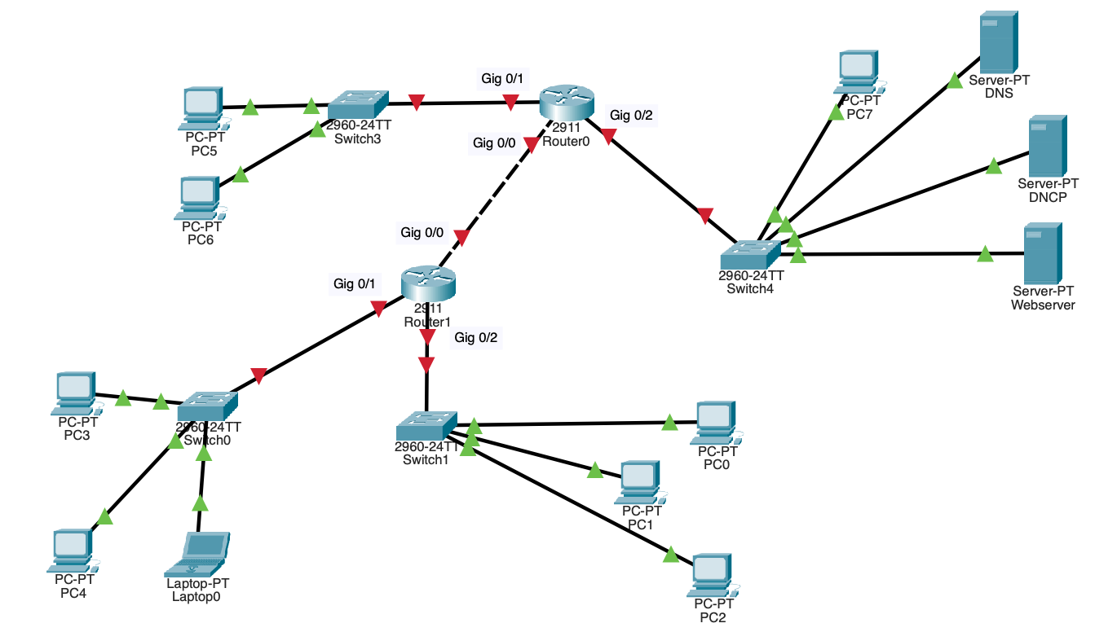

**DHCP Pools:**

|  |  |  |  |  |  |
| --- | --- | --- | --- | --- | --- |
| **Pool Name** | **Default Gateway** | **DNS** | **Start IP address** | **Subnet Mask** | **Max User** |
| **Pool 1** | 192.168.2.1 | 192.168.4.1 | **192.168.2.10** | **255.255.255.0** | **200** |
| **Pool 2** | 192.168.3.1 | 192.168.4.1 | **192.168.3.10** | **255.255.255.0** | **200** |
| **Pool 3** | 192.168.5.1 | 192.168.4.1 | **192.168.5.10** | **255.255.255.0** | **200** |
| **Pool 4** | 192.168.6.1 | 192.168.4.1 | **192.168.6.10** | **255.255.255.0** | **200** |
|  |  |  |  |  |  |

**Addressing table:**

|  |  |  |  |  |  |  |
| --- | --- | --- | --- | --- | --- | --- |
| **Device** | **Interface** | **Network** | **Subnet mask** | **IPv4** | **Default Gateway** | **DNS** |
| **Router 0** | Gig 0/0 | **192.168.7.0** | **255.255.255.0** | **192.168.7.10** | **192.168.7.1** | 192.168.4.1 |
|  | Gig 0/1 | **192.168.8.0** | **255.255.255.0** | **192.168.8.10** | **192.168.8.1** | 192.168.4.1 |
|  | Gig 0/2 | **192.168.9.0** | **255.255.255.0** | **192.168.9.10** | **192.168.9.1** | 192.168.4.1 |
| **Router 1** | Gig 0/0 | **192.168.14.0** | **255.255.255.0** | **192.168.** |  | 192.168.4.1 |
|  | Gig 0/1 | **192.168.5.0** | **255.255.255.0** | **192.168.5.10** | **192.168.5.1** | 192.168.4.1 |
|  | Gig 0/2 | **192.168.6.0** | **255.255.255.0** | **192.168.6.10** | **192.168.6.1** | 192.168.4.1 |
| **DNS** | Fa0 | **192.168.2.0** | **255.255.255.0** | **192.168.2.11** | **192.168.2.1** | 192.168.4.1 |
| **DHCP** | Fa0 | **192.168.2.0** | **255.255.255.0** | **192.168.2.12** | **192.168.2.1** | 192.168.4.1 |
| **Web server** | Fa0 | **192.168.2.0** | **255.255.255.0** | **192.168.2.13** | **192.168.2.1** | 192.168.4.1 |
| **Laptop 0** | Fa0 | **192.168.2.0** | **255.255.255.0** | **192.168.2.14** | **192.168.2.1** | 192.168.4.1 |
| **PC0** | Fa0 | **192.168.11.0** | **255.255.255.0** | **192.168.11.10** | **192.168.11.1** | 192.168.4.1 |
| **PC1** | Fa0 | **192.168.11.0** | **255.255.255.0** | **192.168.11.20** | **192.168.11.1** | 192.168.4.1 |
| **PC2** | Fa0 | **192.168.11.0** | **255.255.255.0** | **192.168.11.30** | **192.168.11.1** | 192.168.4.1 |
| **PC3** | Fa0 | **192.168.2.0** | **255.255.255.0** | **192.168.2.15** | **192.168.2.1** | 192.168.4.1 |
| **PC4** | Fa0 | **192.168.2.0** | **255.255.255.0** | **192.168.2.16** | **192.168.2.1** | 192.168.4.1 |
| **PC5** | Fa0 | **192.168.12.0** | **255.255.255.0** | **192.168.12.10** | **192.168.12.1** | 192.168.4.1 |
| **PC6** | Fa0 | **192.168.12.0** | **255.255.255.0** | **192.168.12.10** | **192.168.12.1** | 192.168.4.1 |
| **PC7** | Fa0 | **192.168.2.0** | **255.255.255.0** | **192.168.2.17** | **192.168.2.1** | 192.168.4.1 |

**Static Routes:**

**Router0:**

**192**

**Router1:**